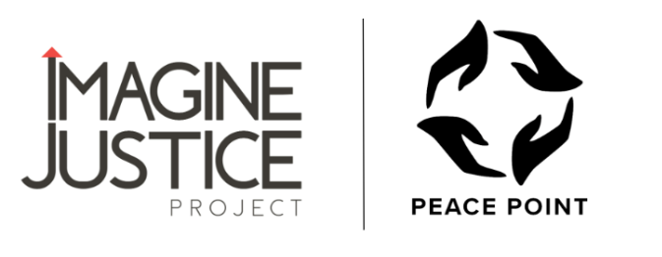

Attachment A: Application Template

Completed applications should be submitted through this online form by 12:00pm on Friday, September 13th, 2024, to be considered. This Word document is for your drafting purposes only. Emailed, mailed, or hand-delivered copies of the Word document will not be accepted. Applications are accepted ONLY through the online form.

SECTION I: APPLICANT INFORMATION
- Organization Name:
- Organization Type (select one)
☐ 501c3 nonprofit
☐ Fiscally sponsored nonprofit
☐ Government
☐ Tribal government or organization
☐ LLC
☐ Other: (please describe)
- Fiscal Sponsor Agency:
If you are fiscally sponsored, please enter the name of your fiscal sponsor organization. Fiscal sponsorships must be formally documented by a written agreement between the two entities. This documentation is not required here but may be requested by Imagine Justice Project for verification if the applicant is selected for funding.
- Federal EIN:
If fiscally sponsored, please enter the EIN for your fiscal sponsor here. Otherwise enter the EIN for the primary applicant agency.
- Annual operating budget:
Enter the annual operating budget for the fiscal year which includes January 2025.
- Organization Website (if applicable):
- Organization Physical Address:
- Organization Mailing Address (if different from above):
- Primary Contact Name:
- Primary Contact Phone Number:
- Primary Contact Email:
- Is Primary Contact the Executive Director or other senior leadership position with the authority to sign contracts on behalf of the organization?
☐ NO – Proceed to Question #13
☐ YES – Skip to Question #16
- Executive Director Name:
- Executive Director Phone:
- Executive Director Email:
SECTION II: ORGANIZATION BACKGROUND & OVERVIEW
There are no character limits to these questions. Please make your answers clear and concise but be sure to fully answer each question. We suggest approximately 1,500 characters per question.
- Mission, vision, and values

- History, background, and overview of programs or services. Include a brief explanation of where in Pierce County your services or programs are offered

- Describe how your staff (or team) reflects the identities and/or experiences of the primary populations you serve. Include how you measure or evaluate this.

SECTION III: PROJECT DESCRIPTION & ALIGNMENT
There are no character limits to these questions. Please make your answers clear and concise but be sure to fully answer each question. We suggest approximately 1,500 characters per question.
- PRIORITY POPULATION: Are you currently serving youth or young adults at the highest risk of being impacted by gun violence in Pierce County? If so, how do you define and identify these individuals? If not, how do you plan to define and identify these individuals?

- CAPACITY BUILDING PROJECT: Please describe your proposed capacity building project. Clearly explain how this project will enhance your organization's ability to serve youth in Pierce County at the highest risk for gun violence. Specifically, how will this project expand the number of youth the organization is able to serve, expand the types of services provided, improve the quality of services provided, and/or improve the efficiency at which the organization is able to provide services?

- ANTICIPATED TIMELINE: The grant period begins November 1, 2024 and ends June 30, 2025. Explain how you intend to implement your project during this time frame.
SECTION IV: PROJECT DESCRIPTION & ALIGNMENT
- Amount Requested:
Note: maximum request is $25,000

- Budget Narrative: Please describe in detail how you anticipate using these funds to complete your capacity building project. Make sure to include whether any outside funding will be used, and if so from what sources. Note: outside funding is not required.

- Project Budget (File Upload)

